**DAY-7**

**Task 1**

package com.DAY7;

import org.openqa.selenium.WebDriver;

import org.openqa.selenium.chrome.ChromeDriver;

import org.openqa.selenium.chrome.ChromeOptions;

import org.testng.Assert;

import org.testng.annotations.Test;

import io.github.bonigarcia.wdm.WebDriverManager;

public class Task1 {

@Test

public void method1() {

WebDriverManager.chromedriver().setup();

ChromeOptions co = new ChromeOptions();

co.addArguments("--remote-allow-origins=*");

WebDriver driver = new ChromeDriver(co);

driver.get("https://demo.wpeverest.com/user-registration/guest-registration-form/");

String actualTitle = driver.getTitle();

String expectedTitle = "Guest Registration Form – User Registration";

Assert.assertEquals(actualTitle, expectedTitle);

}

}

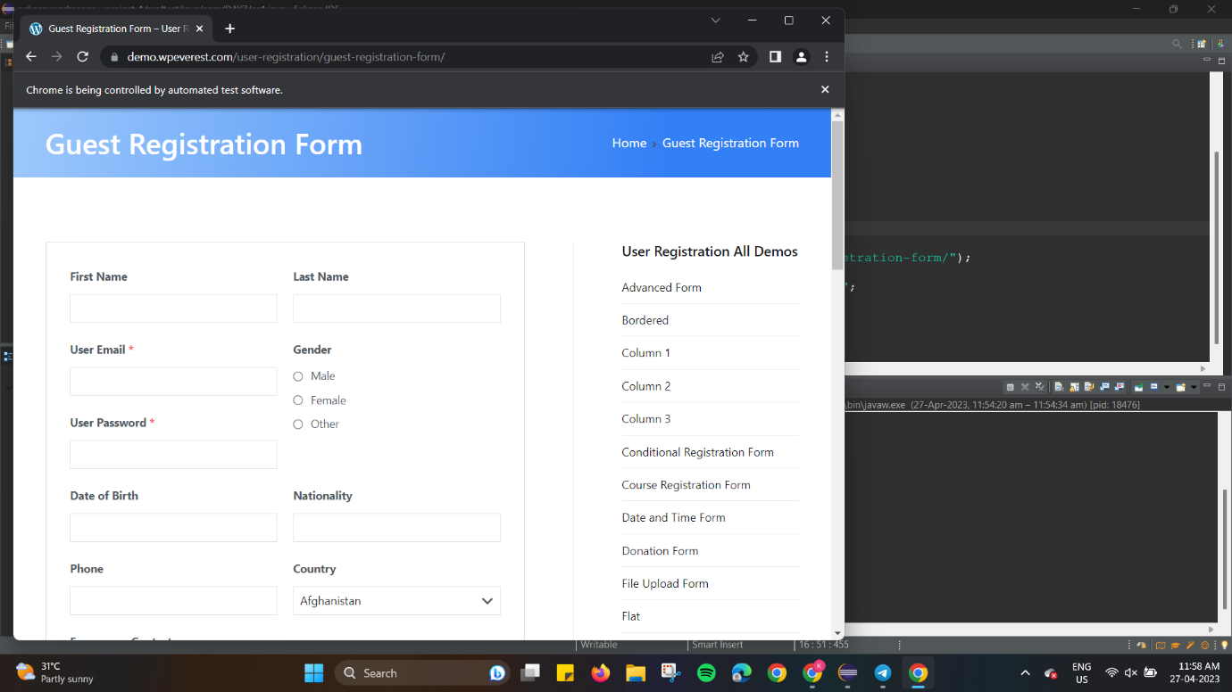

**Task 2**

package com.DAY7;

import org.testng.Assert;

import org.testng.annotations.BeforeSuite;

import org.testng.annotations.Test;

public class Task2 {

int a,b,c;

@BeforeSuite

void getData() {

a = 8;

b = 4;

}

@Test(priority=1)

public void add() {

c = a+b;

Assert.assertEquals(c, 12);

}

@Test(priority=2)

public void subract() {

c = a-b;

Assert.assertEquals(c, 4);

}

@Test(priority=3)

public void multiply() {

c = a*b;

Assert.assertEquals(c, 32);

}

@Test(priority=4)

public void divide() {

c = a/b;

Assert.assertEquals(c, 2);

}

}

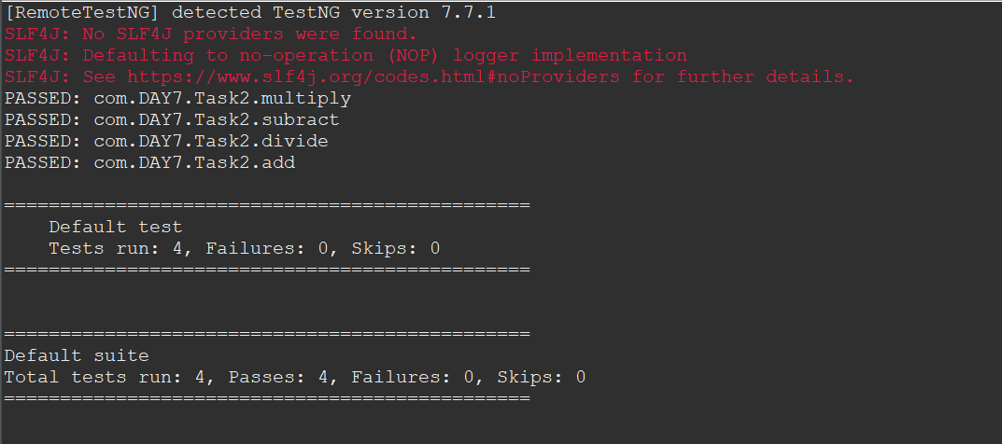

**Task 3**

package com.DAY7;

import org.testng.annotations.Test;

import io.github.bonigarcia.wdm.WebDriverManager;

import org.testng.annotations.BeforeMethod;

import org.testng.annotations.AfterMethod;

import org.openqa.selenium.By;

import org.openqa.selenium.WebDriver;

import org.openqa.selenium.WebElement;

import org.openqa.selenium.chrome.ChromeDriver;

import org.openqa.selenium.chrome.ChromeOptions;

import org.testng.Assert;

public class Task3 {

WebDriver driver;

@Test

public void openURL() throws InterruptedException {

Thread.sleep(3000);

WebElement userName = driver.findElement(By.name("username"));

WebElement password = driver.findElement(By.name("password"));

WebElement submit = driver.findElement(By.xpath("//*[@class='oxd-button oxd-button--medium oxd-button--main orangehrm-login-button']"));

userName.sendKeys("Admin");

password.sendKeys("admin123");

submit.click();

Thread.sleep(3000);

String expectedURL = "https://opensource-demo.orangehrmlive.com/web/index.php/dashboard/index";

String actualURL = driver.getCurrentUrl();

Assert.assertEquals(expectedURL, actualURL);

}

@BeforeMethod

public void setup() {

WebDriverManager.chromedriver().setup();

ChromeOptions co = new ChromeOptions();

co.addArguments("--remote-allow-origins=*");

driver = new ChromeDriver(co);

driver.manage().window().maximize();

String url = "https://opensource-demo.orangehrmlive.com/web/index.php/auth/login";

driver.get(url);

driver.manage().window().maximize();

}

@AfterMethod

public void teardown() {

driver.close();

}

}

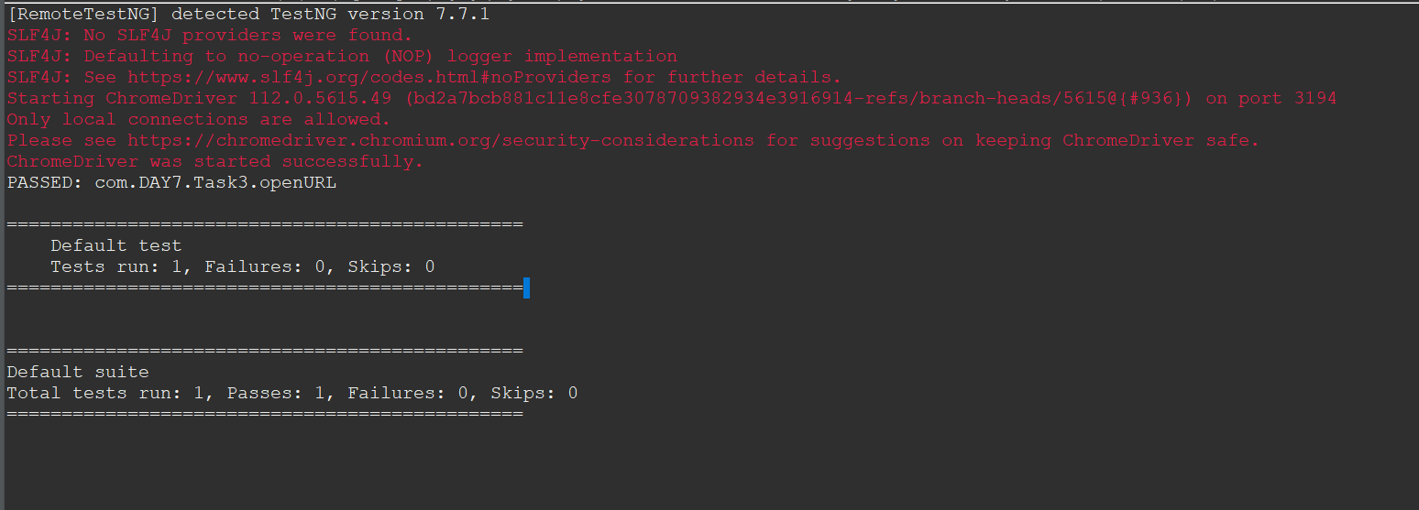

**Task 4:**

package com.DAY7;

import org.openqa.selenium.By;

import org.openqa.selenium.chrome.ChromeOptions;

import org.openqa.selenium.edge.EdgeDriver;

import org.testng.Assert;

import org.testng.annotations.Test;

import io.github.bonigarcia.wdm.WebDriverManager;

public class Task4 {

EdgeDriver driver = new EdgeDriver();

@Test

public void LoginPage() throws InterruptedException {

WebDriverManager.chromedriver().setup();

ChromeOptions co = new ChromeOptions();

co.addArguments("--remote-allow-origins=*");

driver.get("https://opensource-demo.orangehrmlive.com/web/index.php/dashboard/index");

driver.manage().window().maximize();

Thread.sleep(6000);

driver.findElement(By.xpath("//*[@id=\"app\"]/div[1]/div/div[1]/div/div[2]/div[2]/form/div[1]/div/div[2]/input")).sendKeys("Admin");

driver.findElement(By.xpath("//*[@id=\"app\"]/div[1]/div/div[1]/div/div[2]/div[2]/form/div[2]/div/div[2]/input")).sendKeys("admin123");

String str = driver.getCurrentUrl();

driver.findElement(By.xpath("//*[@id=\"app\"]/div[1]/div/div[1]/div/div[2]/div[2]/form/div[3]/button")).click();

String after = driver.getCurrentUrl();

Assert.assertNotEquals(str, after);

}

@Test(dependsOnMethods="LoginPage")

public void Signout() throws InterruptedException {

Thread.sleep(3000);

driver.findElement(By.xpath("//*[@id=\"app\"]/div[1]/div[1]/header/div[1]/div[2]/ul/li/span")).click();

String before = driver.getCurrentUrl();

driver.findElement(By.xpath("//*[@id=\"app\"]/div[1]/div[1]/header/div[1]/div[2]/ul/li/ul/li[4]/a")).click();

String after = driver.getCurrentUrl();

Assert.assertNotEquals(before, after);

}

}

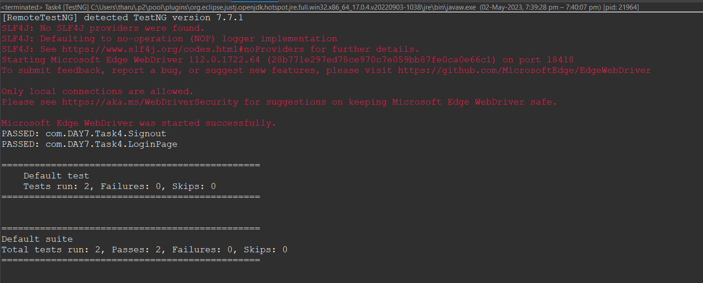

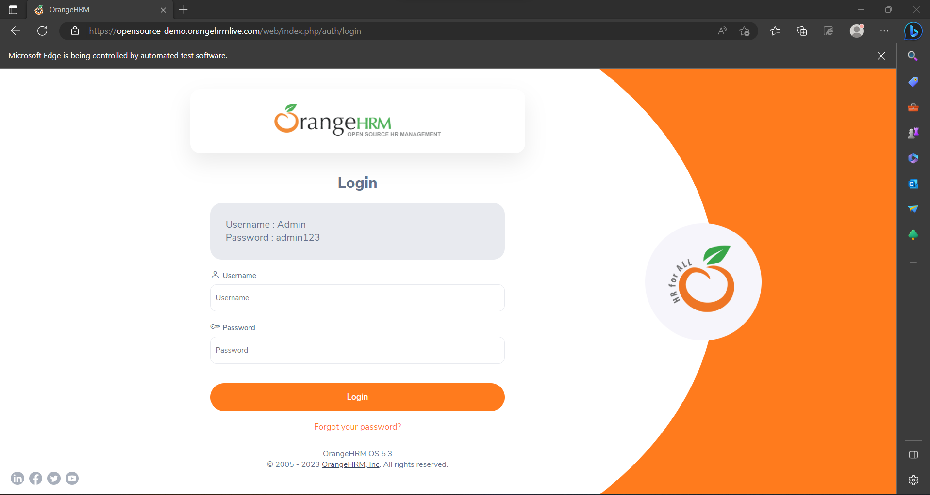

**Task 5:**

package com.DAY7;

import java.util.concurrent.TimeUnit;

import org.openqa.selenium.By;

import org.openqa.selenium.WebDriver;

import org.openqa.selenium.WebElement;

import org.openqa.selenium.chrome.ChromeDriver;

import org.openqa.selenium.chrome.ChromeOptions;

import org.testng.Assert;

import org.testng.annotations.Test;

import io.github.bonigarcia.wdm.WebDriverManager;

public class Task5 {

WebDriver driver;

@Test(groups="SmokeTest")

public void Test1() throws InterruptedException {

WebDriverManager.chromedriver().setup();

ChromeOptions co=new ChromeOptions();

co.addArguments("--remote-allow-origins=*");

driver=new ChromeDriver(co);

driver.get("https://www.godaddy.com/en-in");

driver.manage().window().maximize();

String actTit=driver.getTitle();

System.out.println(actTit);

String expTit="Domain Names, Websites, Hosting & Online Marketing Tools - GoDaddy IN";

Assert.assertEquals(actTit,expTit);

Thread.sleep(1500);

driver.close();

}

@SuppressWarnings("deprecation")

@Test(groups="RegressionTest")

public void Test2() throws InterruptedException {

ChromeOptions co=new ChromeOptions();

co.addArguments("--remote-allow-origins=*");

driver=new ChromeDriver(co);

driver.get("https://www.godaddy.com/en-in");

driver.manage().window().maximize();

driver.manage().timeouts().implicitlyWait(1000,TimeUnit.MILLISECONDS);

WebElement c1=driver.findElement(By.xpath("//*[@id=\"id-631b049a-e9c0-4d24-8710-c504745206dd\"]/button"));

c1.click();

Thread.sleep(1000);

WebElement c2=driver.findElement(By.xpath("//*[@id=\"id-631b049a-e9c0-4d24-8710-c504745206dd\"]/div[2]/div[1]/ul/li[1]"));

c2.click();

Thread.sleep(1000);

WebElement c3=driver.findElement(By.xpath("//*[@id=\"id-631b049a-e9c0-4d24-8710-c504745206dd\"]/div[2]/div[1]/ul/li[1]/div/div[2]/div[1]/ul/li[2]/a"));

c3.click();

Thread.sleep(1000);

driver.close();

}

@SuppressWarnings("deprecation")

@Test(groups="RegressionTest")

public void Test3() throws InterruptedException {

ChromeOptions co=new ChromeOptions();

co.addArguments("--remote-allow-origins=*");

driver=new ChromeDriver(co);

driver.get("https://www.godaddy.com/en-in");

driver.manage().window().maximize();

driver.manage().timeouts().implicitlyWait(1000,TimeUnit.MILLISECONDS);

Thread.sleep(1000);

WebElement c1=driver.findElement(By.xpath("//*[@id=\"id-631b049a-e9c0-4d24-8710-c504745206dd\"]/button"));

c1.click();

Thread.sleep(1000);

WebElement c2=driver.findElement(By.xpath("//*[@id=\"id-631b049a-e9c0-4d24-8710-c504745206dd\"]/div[2]/div[1]/ul/li[1]"));

c2.click();

Thread.sleep(1000);

WebElement c3=driver.findElement(By.xpath("//*[@id=\"id-631b049a-e9c0-4d24-8710-c504745206dd\"]/div[2]/div[1]/ul/li[1]/div/div[2]/div[1]/ul/li[2]/a"));

c3.click();

Thread.sleep(2000);

String x=driver.getTitle();

System.out.println(x);

}

}

